GLENROTHES ART CLUB (SCIO)
Caledonia House
Pentland Park
Saltire Centre
Glenrothes
KY6 2AL

Tel: 01592 56 21 09
Email: glenrothesartclub@gmail.com
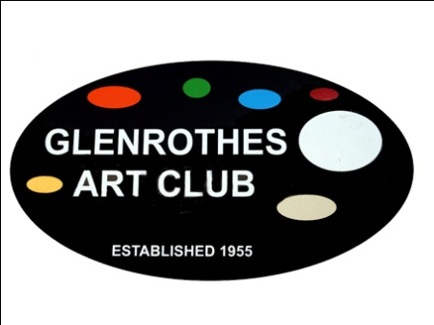

Equal Opportunities Policy

Introduction
Glenrothes Art Club is a Scottish Charitable Incorporated Organisation encouraging and facilitating the practice of arts and crafts.

Statement of Policy
The aim of this policy is to communicate Glenrothes Art Club’s commitment to the promotion of equal opportunity within the organisation.

It is our aim to provide equality to all. In particular, the organisation is committed to promoting equal treatment irrespective of age, colour, disability, ethnic origin, family status, gender, marital status, nationality, political belief, race, religion, or sexual orientation.

We are opposed to all forms of unfair and unlawful discrimination.

We recognise that the provision of equal opportunities in the Art Club is good practice. Our equal opportunities policy will help all members and visitors to develop their full potential.

We are committed to:
- preventing direct or indirect discrimination or victimisation.
- promoting equal opportunities for all
- promoting a good and harmonious environment where everyone is treated with respect and dignity and in which no form of intimidation or harassment will be tolerated.
- fulfilling all legal obligations under the relevant legislation and associated codes of practice; and,
- taking any necessary positive or affirmative action.

Breaches of our equal opportunities policy and practice will be regarded as serious and could lead to disciplinary proceedings.

Responsibility
The Board of Glenrothes Art Club has overall responsibility for the Equal Opportunities Policy. Responsibility for its implementation is shared by all members of Glenrothes Art Club and visitors to Glenrothes Art Club.
Implementation Date: _____________________

Review Date: ___________________________

Signed: ________________________________
(for and on behalf of the Board)

Visit our website: www.glenrothesartclub.org.uk
Facebook: Glenrothes Art Club
Twitter: @GlenrothArtClub

