GLENROTHES ART CLUB (SCIO)
Caledonia House
Pentland Park
Saltire Centre
Glenrothes
KY6 2AL

Tel: 01592 56 21 09
Email: glenrothesartclub@gmail.com
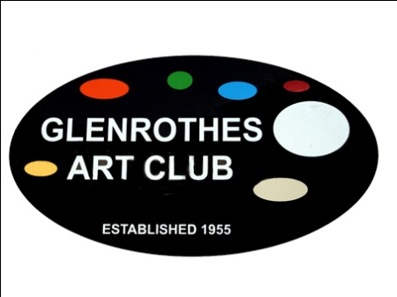

Protection of Vulnerable Adults

Policy and Procedure

Policy Statement

Glenrothes Art Club is a Scottish Charitable Incorporated Organisation encouraging and facilitating the practice of arts and crafts.

Glenrothes Art Club is open to all adults and recognises that some of these people could come within the definition of Vulnerable Adult.

- Introduction

The characteristics of adult abuse can take a number of forms and cause victims to suffer pain, fear and distress reaching well beyond the time of the actual incident(s). Victims may be too afraid or embarrassed to raise any complaint. They may be reluctant to discuss their concerns with other people or unsure who to trust or approach with their worries.

There may be some situations where victims are unaware that they are being abused or have difficulty in communicating this information to others.

- Aim of Policy
The aim of this policy is to ensure the safety of vulnerable adults by outlining clear procedures and ensuring that all Art Club members and users are clear about their responsibilities.

- Responsibilities
All members and users have a responsibility to be aware of this policy and to report any suspicions that they might have concerning adult abuse.

- Definition
A vulnerable adult is a person aged 18 years or over who may be unable to take care of themselves or protect themselves from harm or from being exploited.

This may include a person who:
  - Is elderly and frail
  - Has a mental illness including dementia
  - Has a physical or sensory disability
  - Has a learning disability
  - Has a severe physical illness
  - Is a substance misuser
  - Is homeless

- What is abuse?
Abuse is a violation of an individual’s human and civil rights by any other person or persons. It can take a number of forms:

- Physical abuse e.g. hitting, pushing, shaking, inappropriate restraint, force-feeding, forcible administration of medication, neglect or abandonment
- Sexual abuse e.g. involvement in any sexual activity against his/her will, exposure to pornography, voyeurism and exhibitionism
- Emotional/psychological abuse e.g. intimidation or humiliation
- Financial abuse e.g. theft or exerting improper pressure to sign over money from pensions or savings etc.
- Neglect or acts of omission e.g. being left in wet or soiled clothing, or malnutrition
- Discriminatory abuse e.g. racial, sexual or religious harassment
- Personal exploitation – involves denying an individual his/her right or forcing him/her to perform tasks that are against his/her will
- Violation of rights e.g. preventing an individual speaking his/her thoughts and opinions
- Institutional abuse e.g. failure to provide a choice of meals or failure to ensure privacy or dignity

- Rights of Vulnerable Adults
The vulnerable adults have the right to:

- be made aware of this policy
- to have alleged incidents recognised and taken seriously
- to receive fair and respectful treatment throughout
- to be involved in any process as appropriate
- to receive information about the outcome.

- Reporting Procedures
All those making a complaint, allegation, or expression of concern, whether
Glenrothes Art Club members, users, carers or members of the public should be reassured that they:

- will be taken seriously
- their comments will usually be treated confidentially but their concerns may be shared if they or others are at significant risk
- if service users, they will be given immediate protection from the risk of reprisals or intimidation

If an allegation is made to a member or there is a suspicion of abuse then the member should inform the Management Committee as soon as possible.

A written record should be made of the allegation or suspicion of abuse (see appendix 1) and contact made with local Social Services.

If there is any doubt about whether or not to report an issue to Community Social Services then it should be reported.

In emergency situations (e.g. where there is the risk or occurrence or severe physical injury), where immediate action is needed to safeguard the health or safety of the individual or anyone else who may be at risk, the emergency services must be contacted.

Where a crime is taking place, has just occurred or is suspected, the police must be contacted immediately.

- Related Policies
Data Protection Policy

Implementation Date: _____________________

Review Date: ___________________________

Signed: ________________________________
(for and on behalf of the Management Committee)

Visit our website: www.glenrothesartclub.org.uk
Facebook: Glenrothes Art Club
Twitter: @GlenrothArtClub

Appendix 1

Incident Report Form

Name of Person Making This Complaint:

…………………………………………………………………………..

Role:……………………………………………………………………………..

Address:

Telephone:

Briefly describe what happened (include times and dates):

Names and contacts of witnesses:

Name of person completing form:

Date:

Action taken:

