GLENROTHES ART CLUB (SCIO)
Caledonia House
Pentland Park
Saltire Centre
Glenrothes
KY6 2AL

Tel: 01592 56 21 09
Email: glenrothesartclub@gmail.com
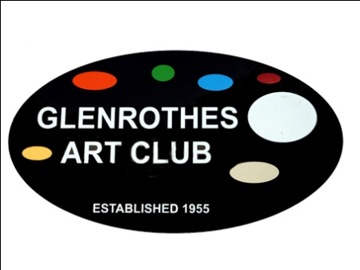

Volunteer Policy

1. Introduction

Policy Statement
Glenrothes Art Club (SCIO) is a Scottish Charitable Incorporated Organisation encouraging and facilitating the practice of arts and crafts.

Volunteers make a vital contribution to our aims. We recognise the added value that volunteers bring to our organisation and those who use our services

Within Glenrothes Art Club (SCIO) volunteers are involved in:
- Board of Management
- A variety of roles undertaken by members of the Art Club

Glenrothes Art Club (SCIO) aims to have a reciprocal and mutually beneficial relationship with our volunteers; with their involvement informing and developing our work, and our work enabling individuals to learn skills and achieve personal development through their volunteering.

The involvement of volunteers will be guided by the following principles of good practice:
- the tasks to be performed by volunteers will be clearly defined, so that everyone is sure of their respective roles and responsibilities;
- the organisation will comply with the Data Protection Act in the use of data held on all volunteers;
- volunteers will be provided with regular opportunities to share ideas/concerns with the Board regarding roles that they are undertaking;
- all existing and future policies will be checked as to how they affect volunteers

2. The Purpose of this Policy
By adopting this policy Glenrothes Art Club (SCIO) aims to:
- highlight and acknowledge the value of the contribution made by volunteers;
- reflect the purpose, values, standards and strategies of the organisation in its approach to involving volunteers;
- recognise the respective roles, rights and responsibilities of volunteers;
- confirm this organisation’s commitment to involving volunteers in its work;
- establish clear principles for the involvement of volunteers; and
- ensure the ongoing quality of both the volunteering opportunities on offer and the work carried out by our volunteers.

This policy provides an overview of the activities carried out by volunteers currently and provides a basis for the expansion, if required, for the role of volunteers. This document and the associated policy, procedures and guidance provide a framework for the involvement of volunteers.

3. Recruitment and Selection
Glenrothes Art Club (SCIO) will adhere to its equal opportunities policy when recruiting and selecting volunteers.

4. Support and Supervision
Once placed, we will expect volunteers to comply with existing policies and procedures. All volunteers are covered under Glenrothes Art Club (SCIO)’s Public Liability Insurance.
Volunteers can expect to be given guidance and support in carrying out their agreed roles and duties.

Volunteers will be able to claim reasonable expenses for their volunteering in line with the policy of Glenrothes Art Club (SCIO). Volunteers should discuss any planned expenditure prior to incurring expense to ensure that it will be covered by the organisation.

5. Problem Solving
Where a concern is highlighted – either by a volunteer or about a volunteer, this will be dealt with by the Board of Glenrothes Art Club (SCIO).

6. Responsibility
Overall responsibility for the implementations, monitoring and review of the policy and procedures lies with the Board of Glenrothes Art Club (SCIO). Implementation and adherence to this policy is the responsibility of all members and volunteers within the organisation.

Implementation Date: _____________________

Review Date: ___________________________

Signed: ________________________________
(for and on behalf of the Board)

Visit our website: www.glenrothesartclub.org.uk
Facebook: Glenrothes Art Club (SCIO)
Twitter: @GlenrothArtClub

